Appendix 8C-17 Inlet Control,

Corrugated Metal Box,

0.3≤ Rise/Span <0.4
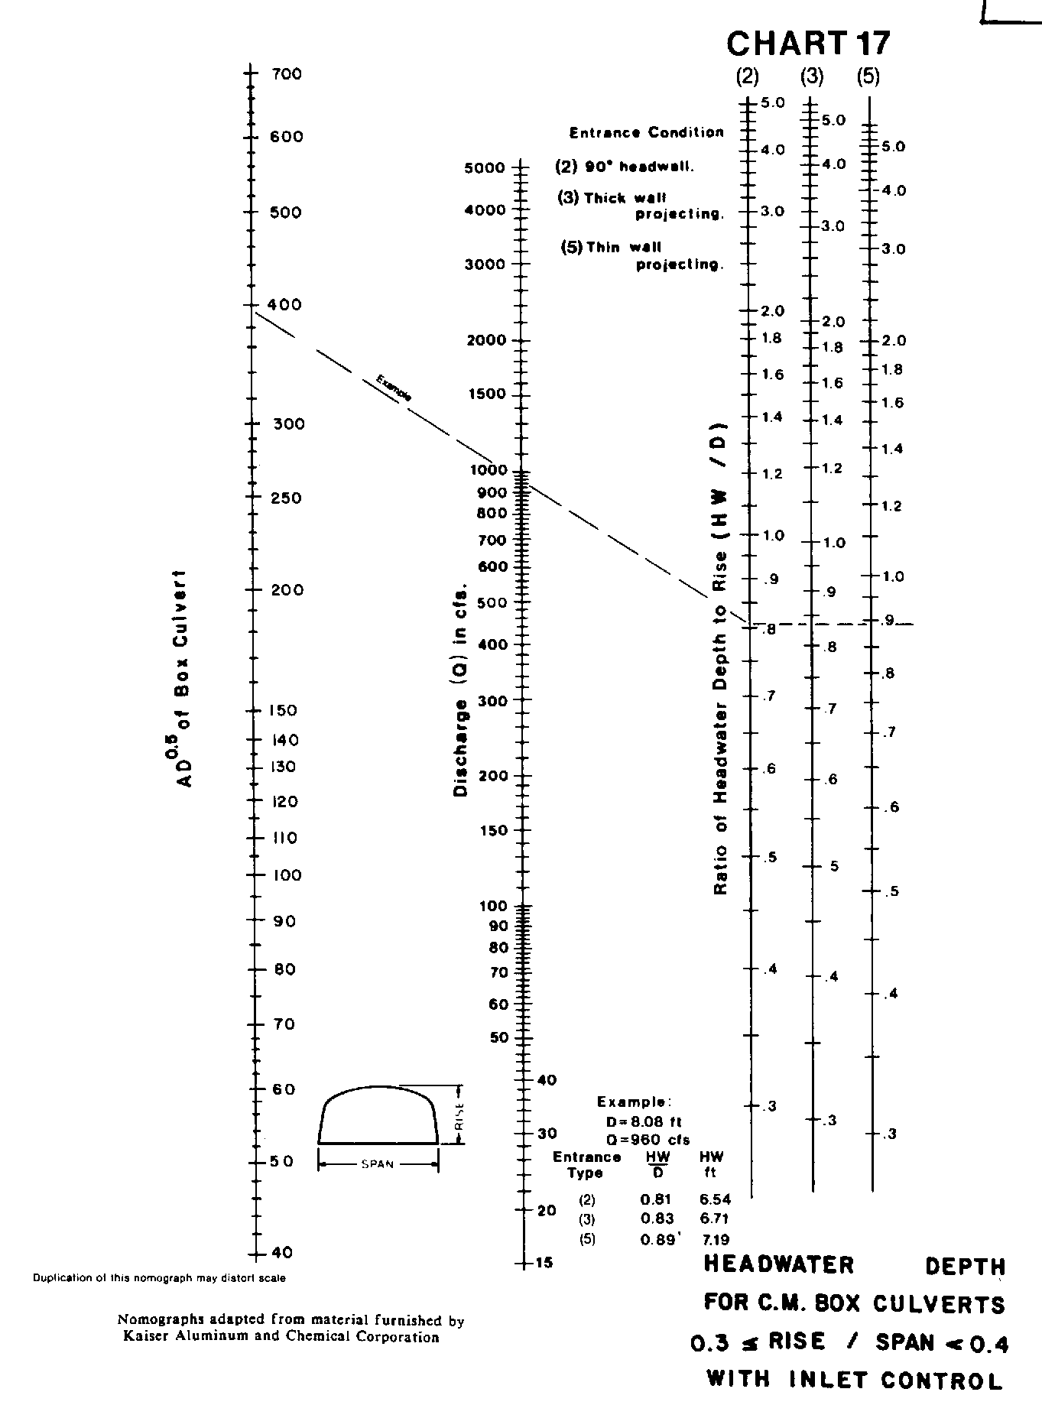

Source: HDS-5

