Appendix 8C-15 Outlet Control, Concrete Box
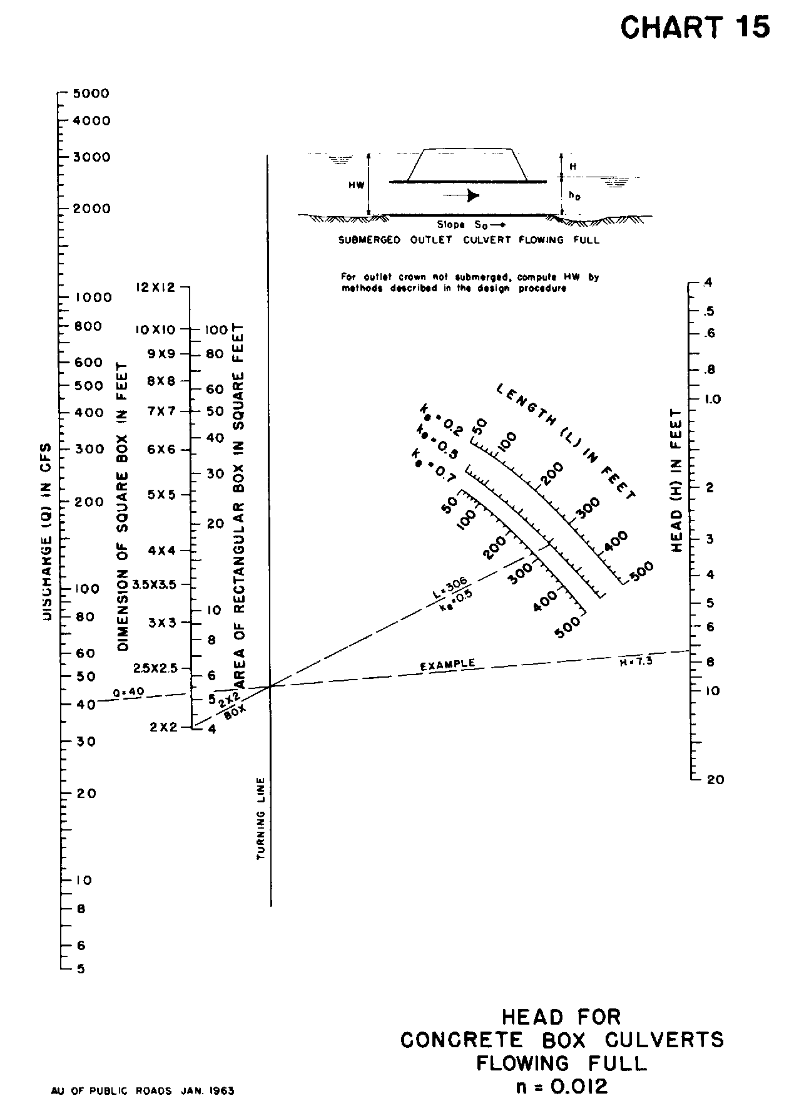

Source: HDS-5

