Appendix 8C-1 Inlet Control, Circular Concrete

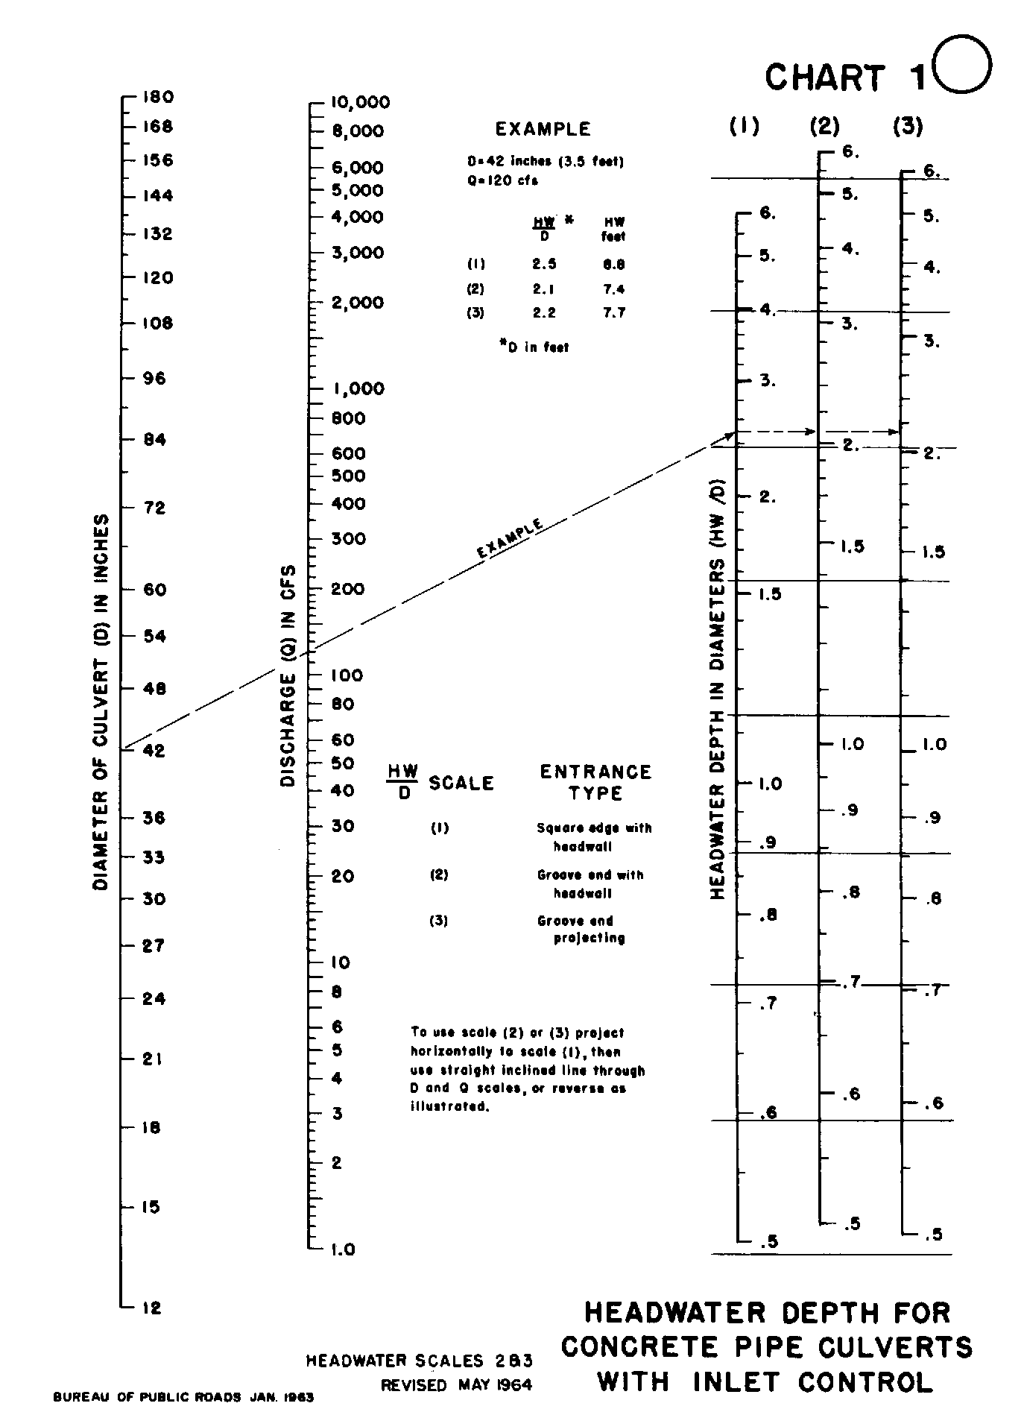

Source: HDS -5

