Appendix 7E-9 Determination of Mean Spherical Diameter

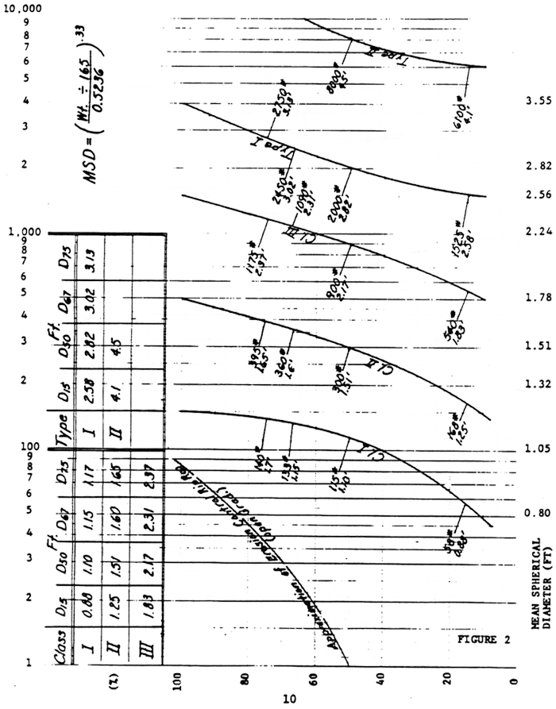

Source: VDOT
Comment: Use this chart to obtain D₇₅ information for the Channel Stability Worksheet (Appendix 7B-3).

