Appendix 7E-3 Permissible Shear Stress for Cohesive Soils

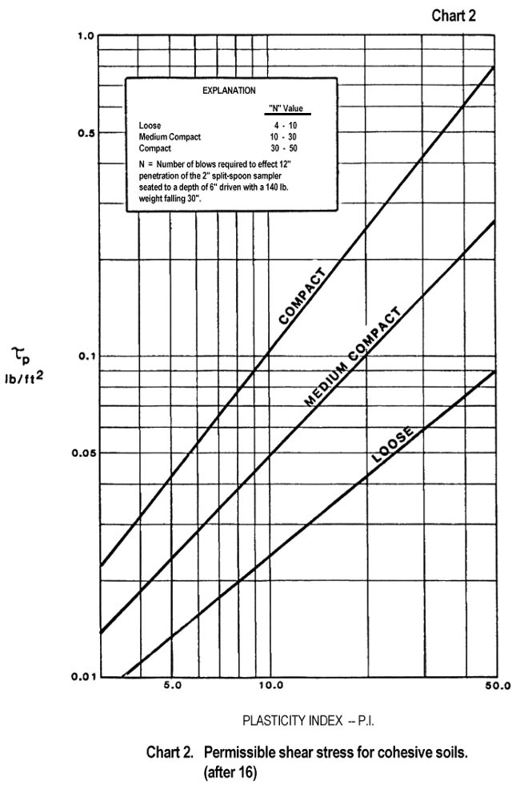

Source: HEC-15

