Appendix 7E-2 Permissible Shear Stress for Non-Cohesive Soils

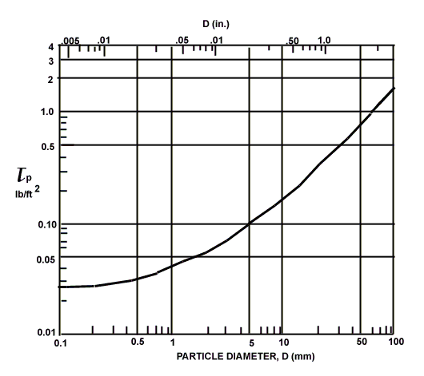

Source: HEC-15

