Appendix 7C-24 Trapezoidal Channel Flow Chart

(B = 8’, Side Slopes = 2:1)

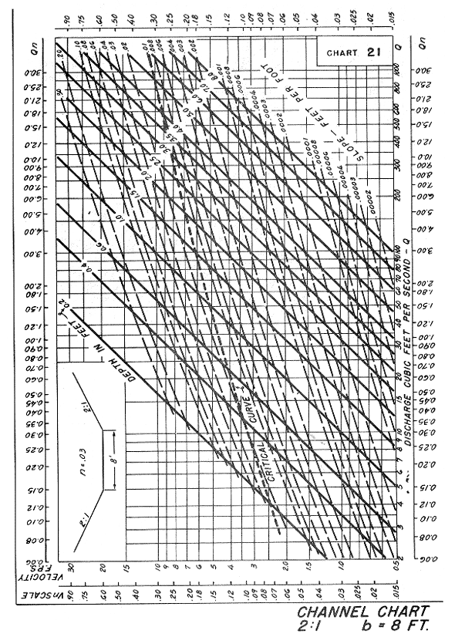

Source: HDS-3

