Appendix 7C-19 Trapezoidal Channel Flow Chart

(B=3’, Side Slopes = 2:1)

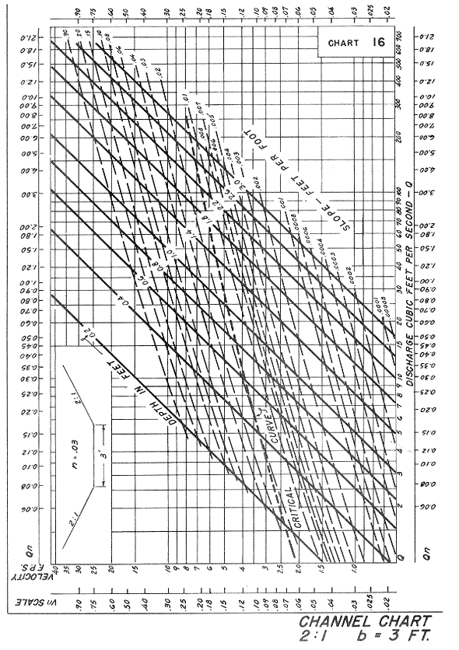

Source: HDS-3

