Appendix 7C-18 Trapezoidal Channel Flow Chart

(B=2’, Side Slopes = 2:1)

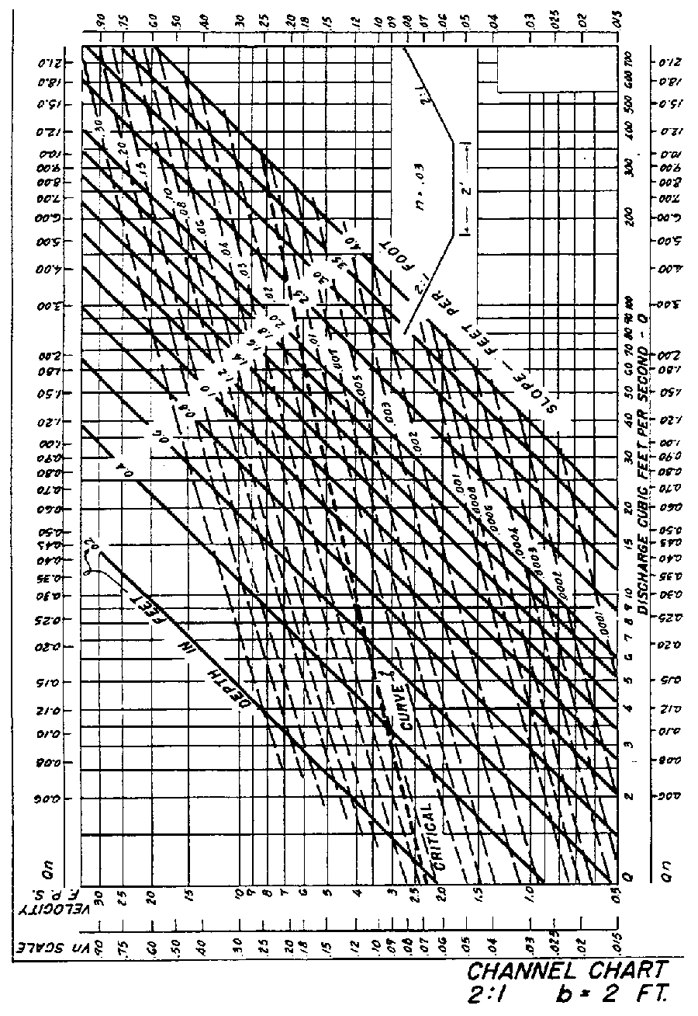

Source: HDS-3

