Appendix 7C-16 Standard PG-4 Flow Chart

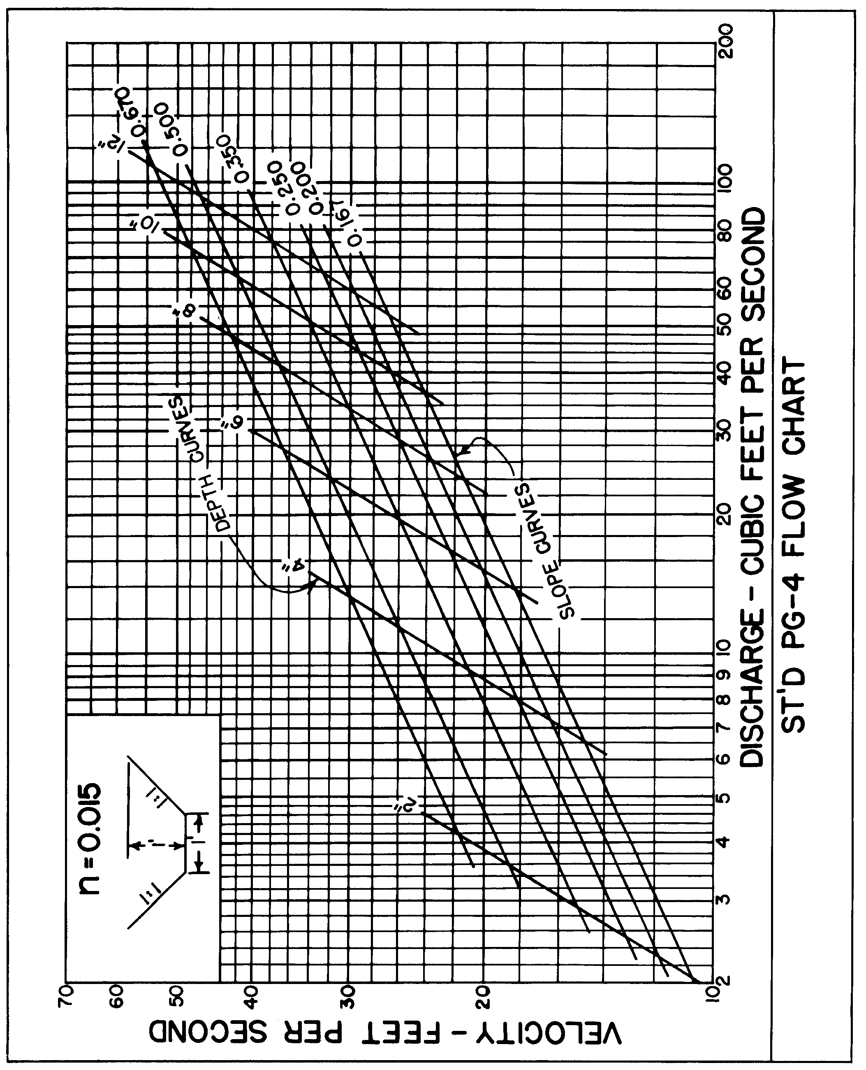

Source: VDOT

