Appendix 7C-9 Side Ditch Flow Chart

(Side Slopes = 3:1, 2:1)
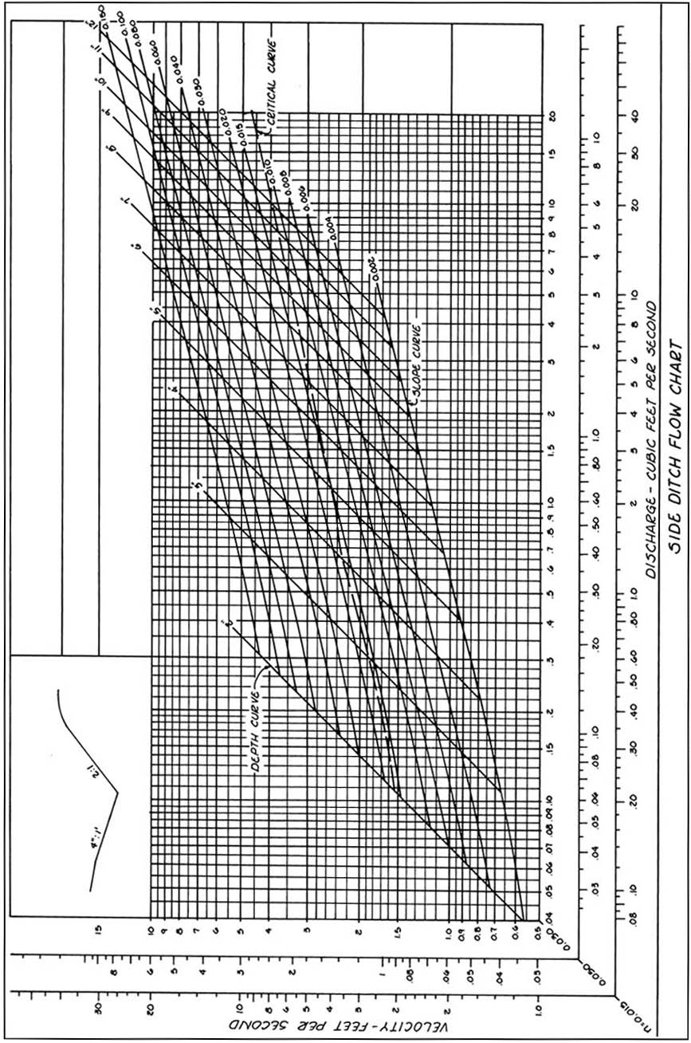
Source: VDOT

