Appendix 7C-6 Side Ditch Flow Chart

(Side Slopes = 4:1, 1.5:1)

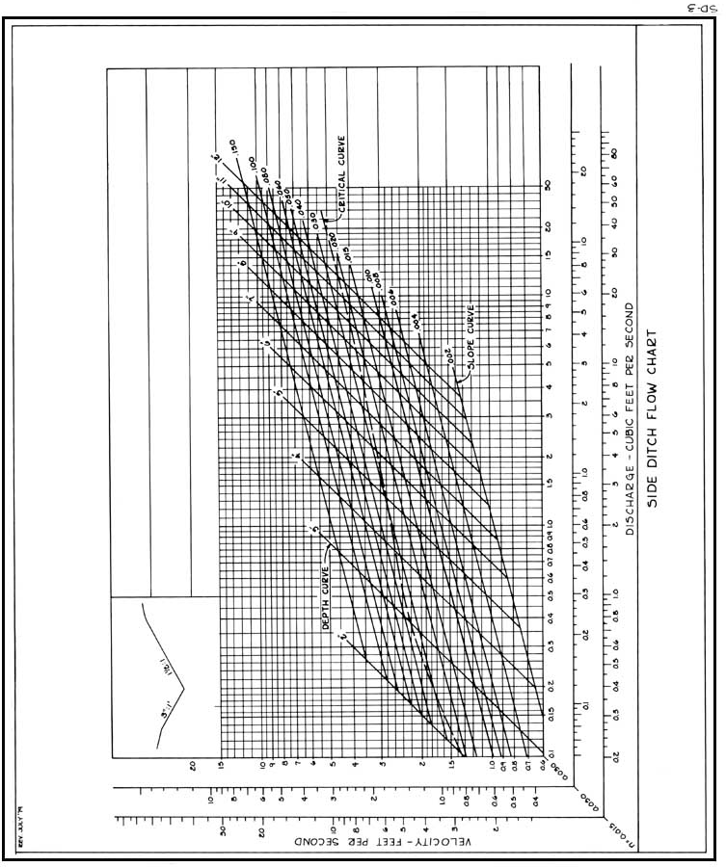
Source: VDOT

