Appendix 6G-11 Snyder Method: Winchester County Rainfall Depth Curve

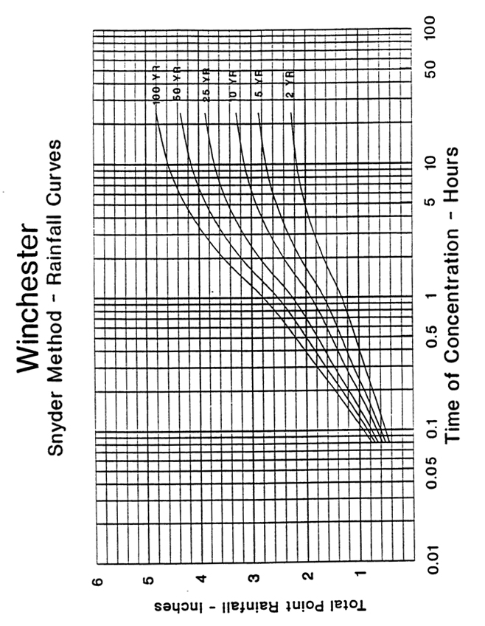

Source:

