Appendix 6G-8 Snyder Method: Richmond (City)

Rainfall Depth Curve
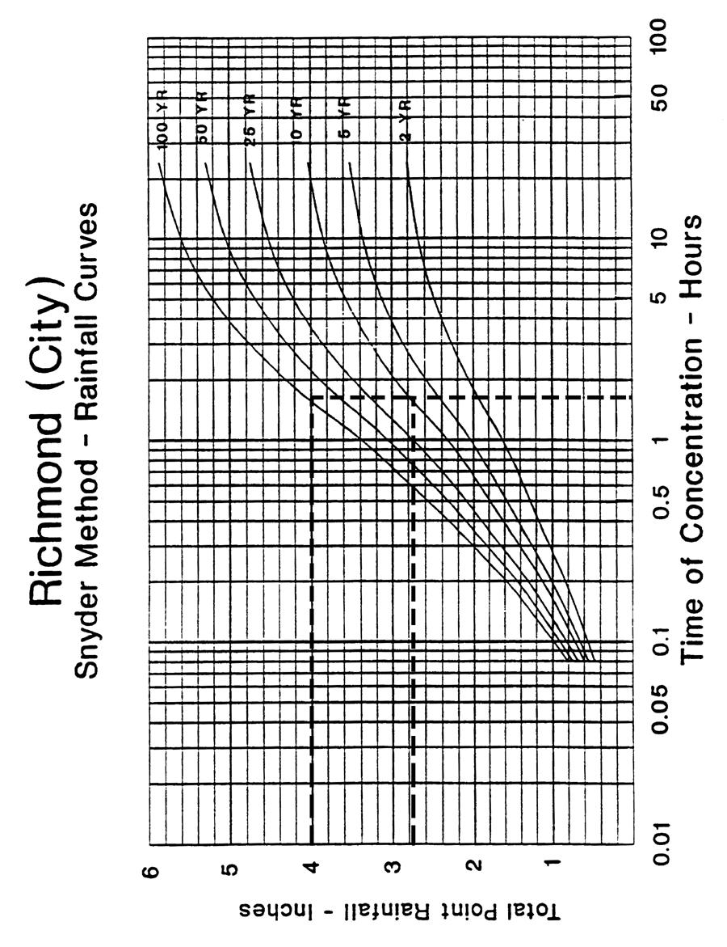

Source:

