Appendix 6G-1 Total Runoff vs. % Direct Runoff

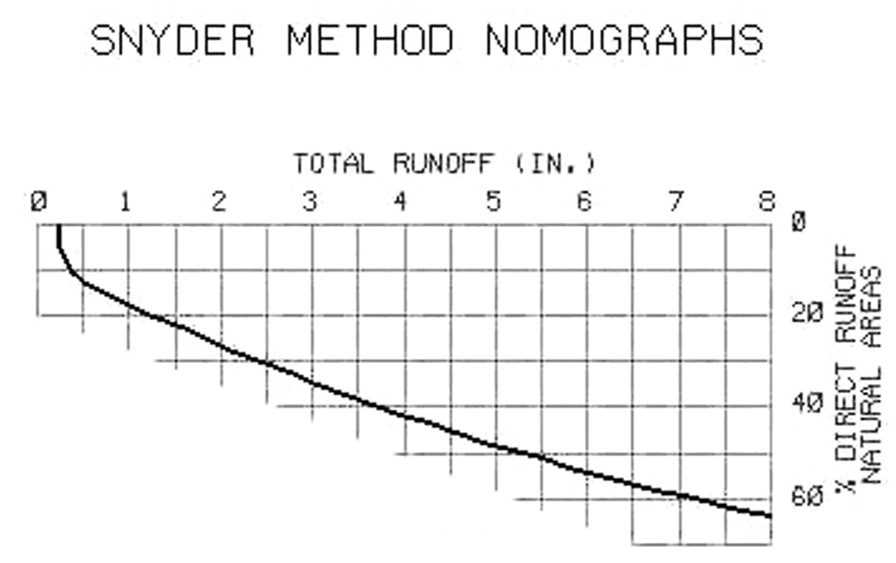

Source:

