Appendix 6B-9 Rainfall Intensity Inches Per Hour

Lynchburg
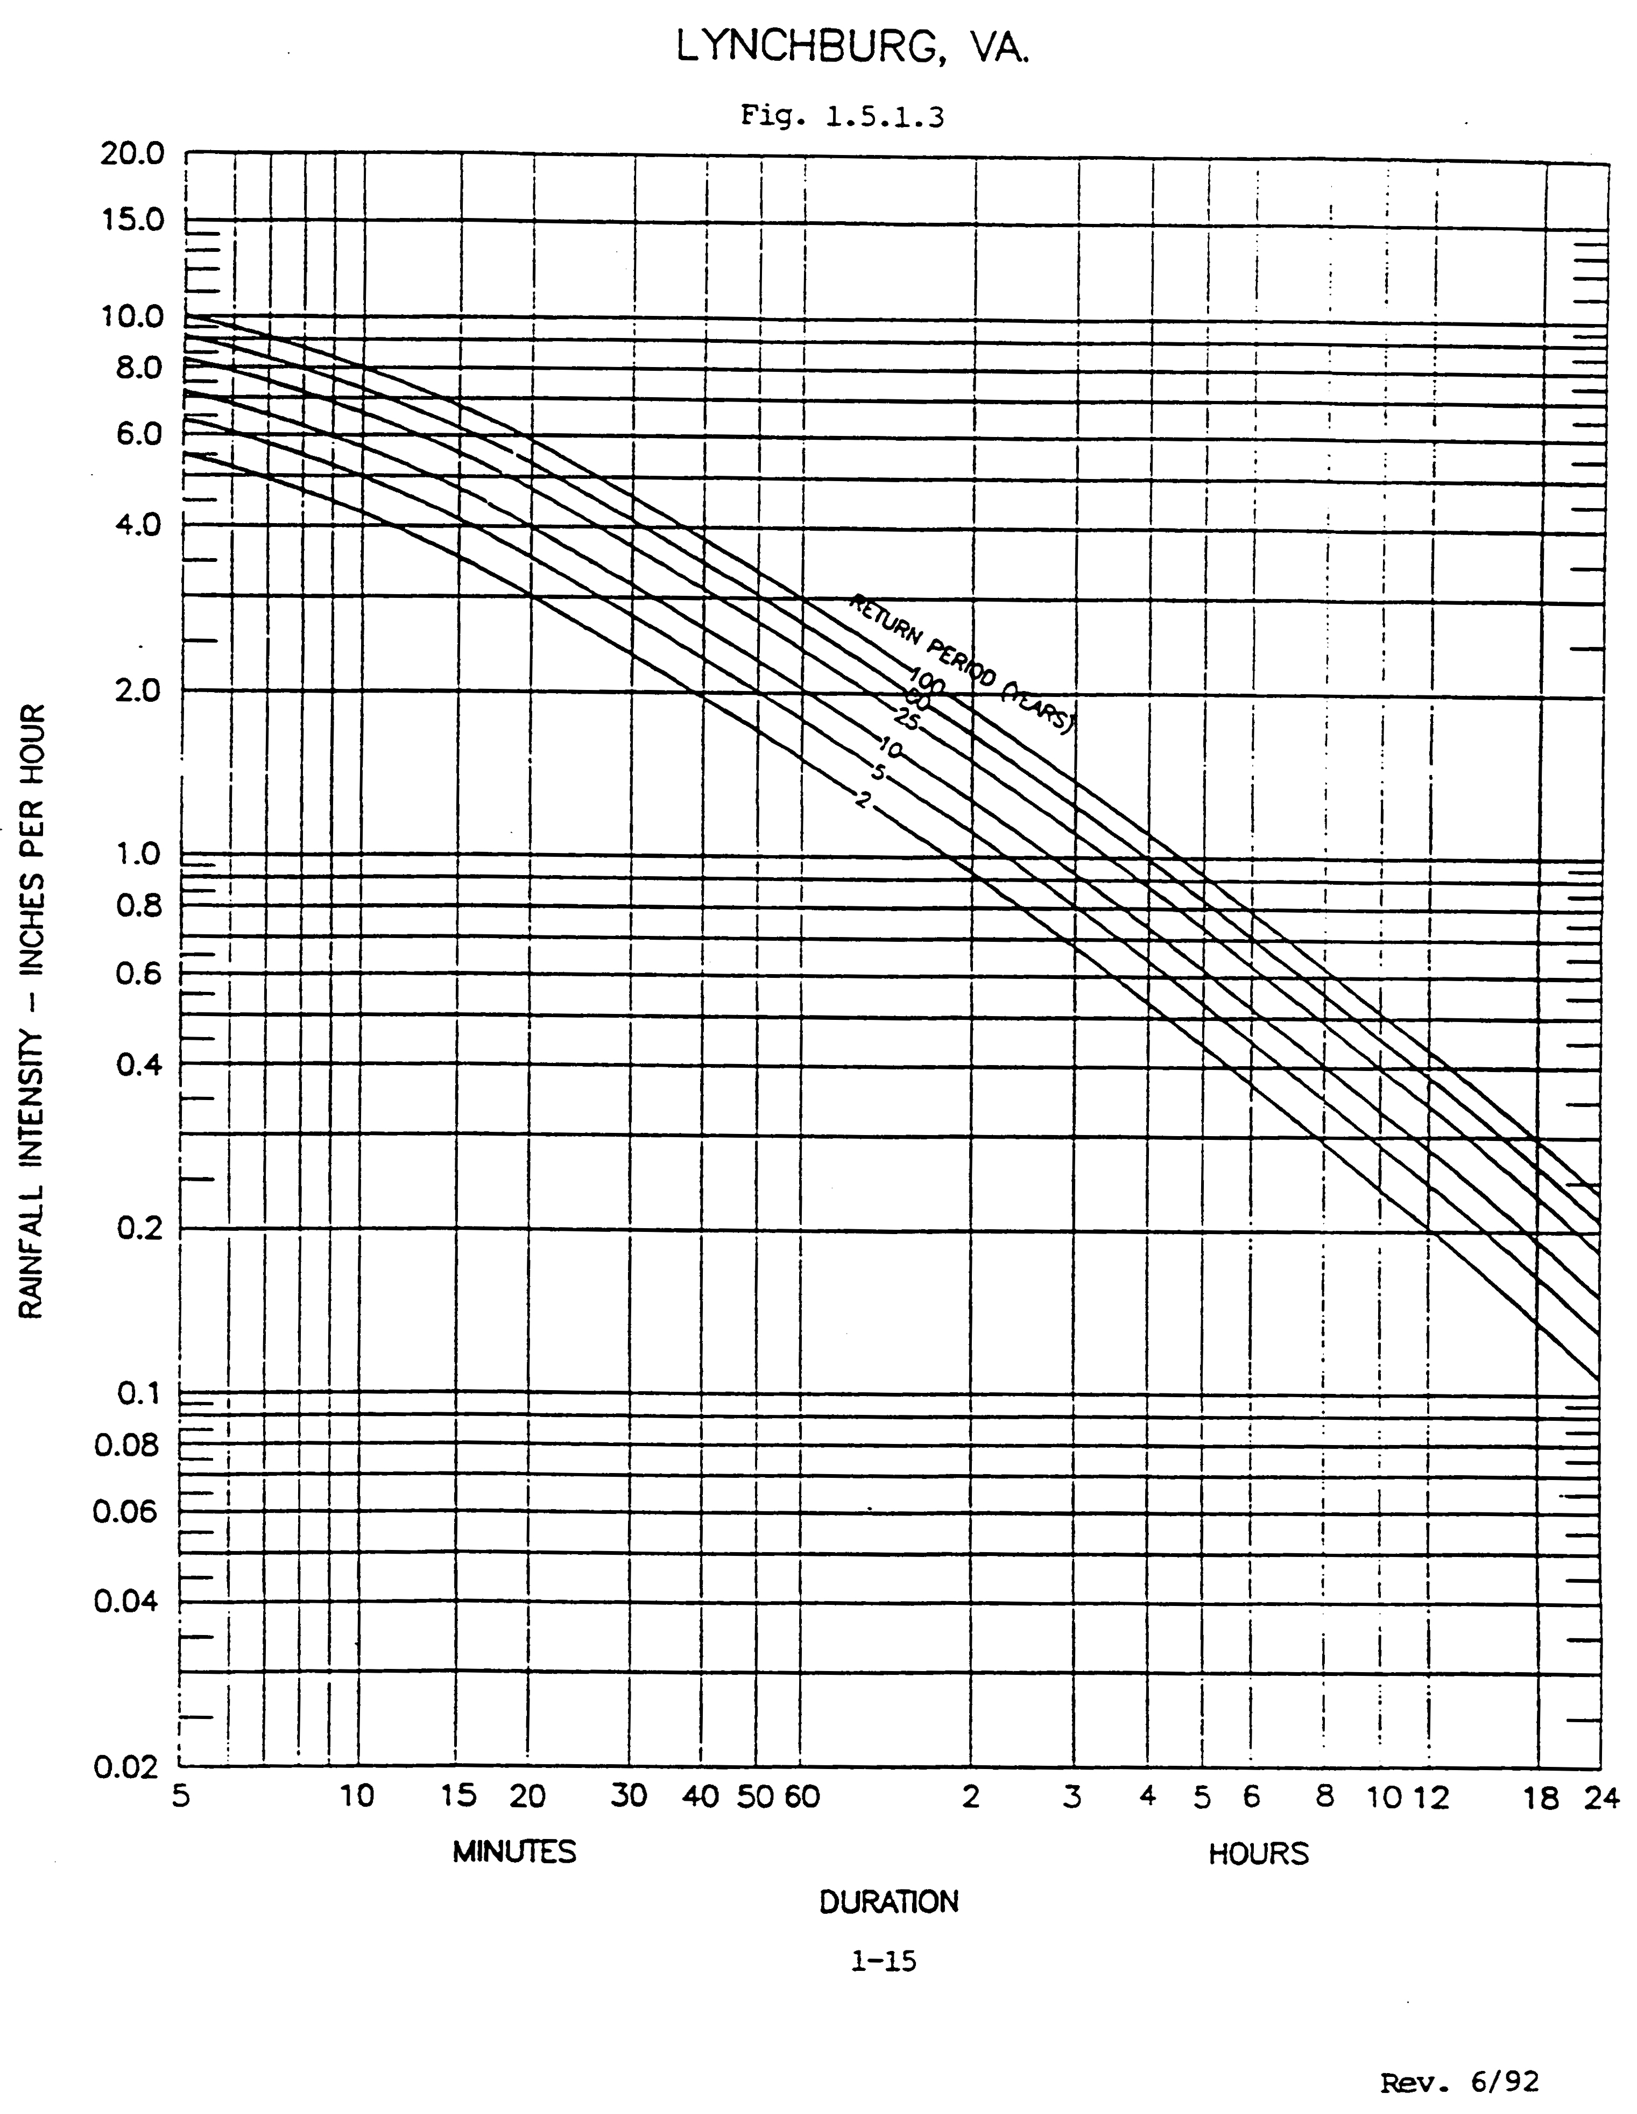

Regression Constants

Freq. | a | b
2 | 110.26 | 15.76
5
10 | 167.27 | 19.18
25
50
100 | 252.65 | 21.56

Source:
Regression Constants from Virginia Stormwater Management Handbook, 1st Ed., Vol. II, 1999

