Appendix 6B-4 Rainfall Intensity Inches Per Hour

Arlington Co.

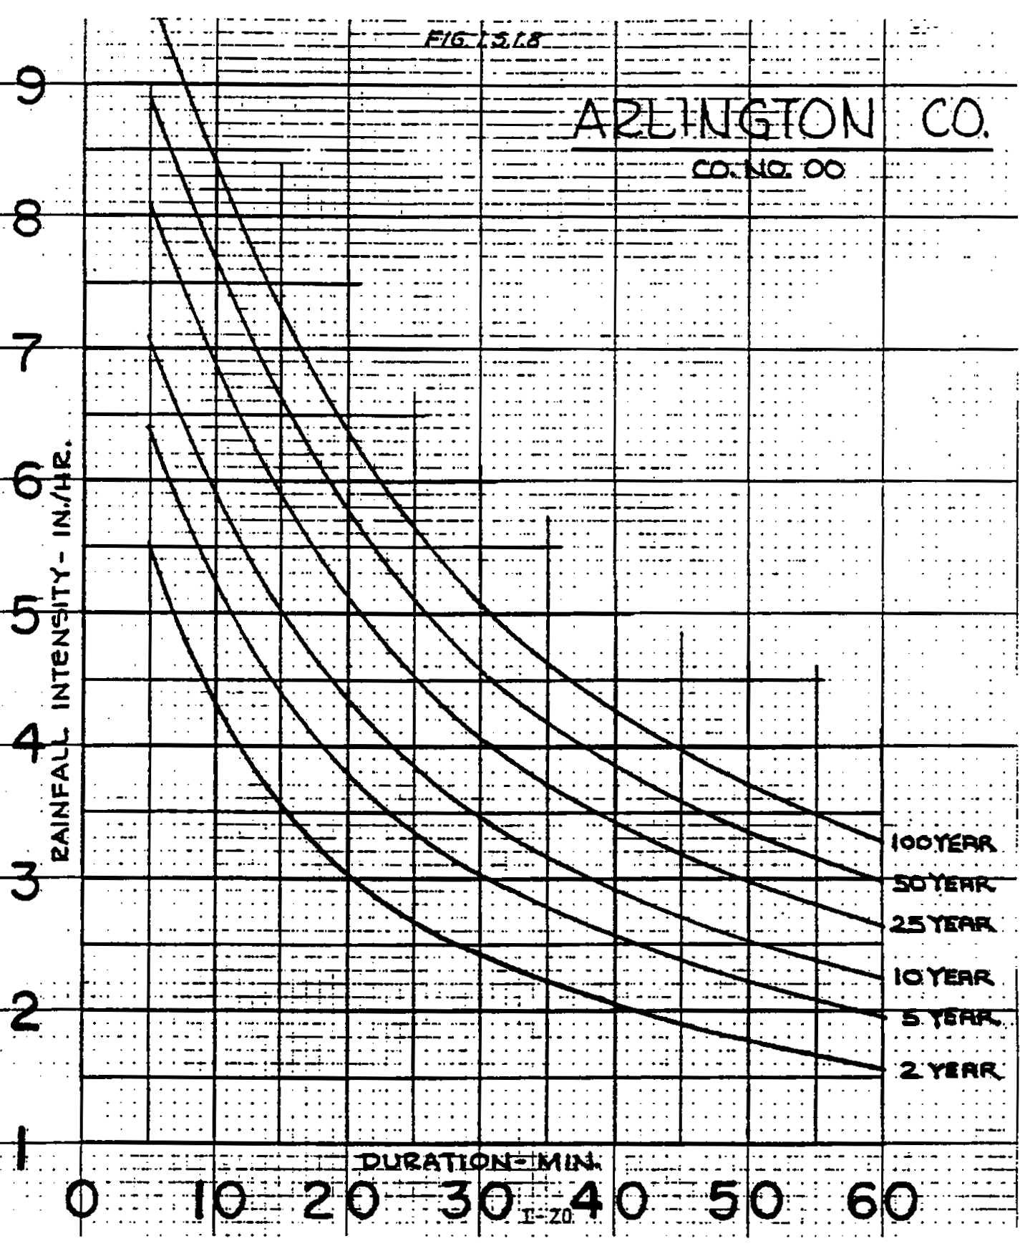

Regression Constants

Freq. | a | b
2 | 119.34 | 17.86
5
10 | 178.78 | 20.66
25
50
100 | 267.54 | 22.32

Source:
Regression Constants from Virginia Stormwater Management Handbook, 1st Ed., Vol. II, 1999

